**Lab – Join Server 2012 R2 Core to an Existing Domain**

**Overview**

In this lab, you will join an install of Server 2012 Core to your existing Windows Server 2012 r2 virtual lab environment. Server Core is a minimal server installation option for Windows Server that provides a low-maintenance server environment with limited functionality. Starting with Windows Server 2012, it is possible to transition between Full Server and Server Core without reinstalling the operating system.

The following table lists the benefits of Server Core for Windows Server 2012 R2.

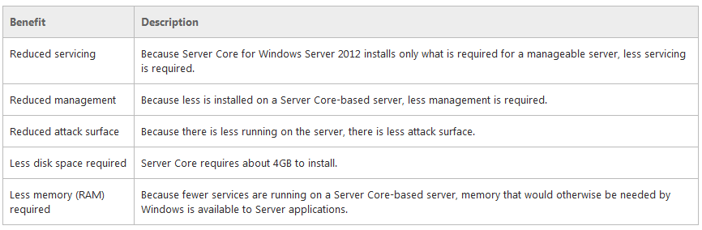

Lab Requirements:

Students need a fresh Server Core installation of Windows Server 2012 r2 with the following default settings:

* A hostname as a random name, beginning with **WIN-** followed by 11 random characters to form the maximum allowed 15-character NetBIOS name.
* It is a member of the WORKGROUP, workgroup.
* Its network interface cards are set to request an IPv4 IP address from a DHCP server. If it does not receive an IP address from a server, it will configure a 169.254.x.y Automatic Private IP Address with the 16-bit subnet mask, as defined in RFC 3927. IPv6, by default, is enabled for a fe80 site-local link. 6to4 is disabled.
* Remote Management through both WINRS and WINRM is enabled by default for the local network. Remote Desktop is disabled by default.
* Windows Update is set to manual by default.
* Its default time zone is (UTC -8:00) Pacific Time (U.S. and Canada) and is set to synchronize with time.windows.com. By default, you will be notified when the clock changes.
* The Customer Experience Improvement Program (CEIP) is not joined.

**Changing the IPv4 address**

Logon to your install of Server 2012 Core.

At the command prompt of Server Core, type **sconfig.cmd.**

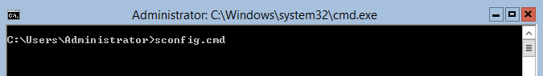

We begin by renaming the Server Core with a much friendlier name. In this example, I rename this server to DC2.

From the Server Configuration menu, select option number 2. Hit enter and on the next window, type in your new server name.

Rename the server. Hit enter.

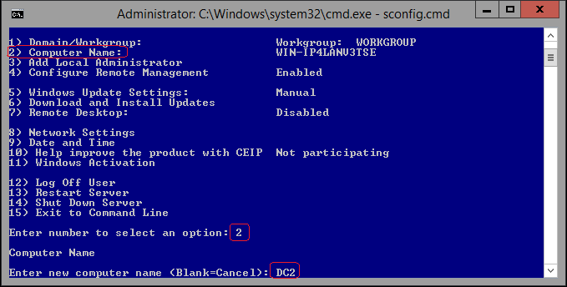

Restart the server for the changes to take effect.

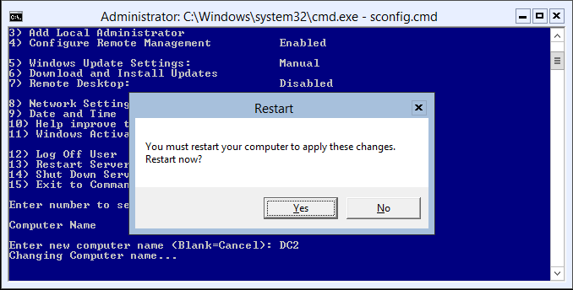

Login back onto your renamed core server and at the command prompt, run the sconfig.cmd command to confirm your machine has been renamed. Exit the sconfig utility and return to the command prompt.

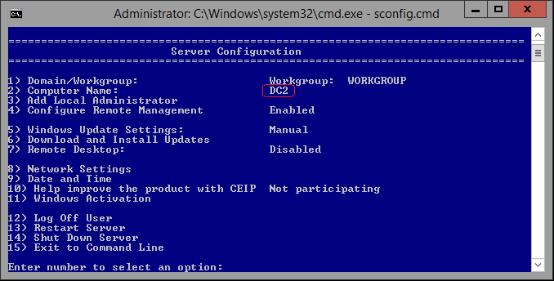

At the prompt, check your current IP address by typing IPCONFIG.

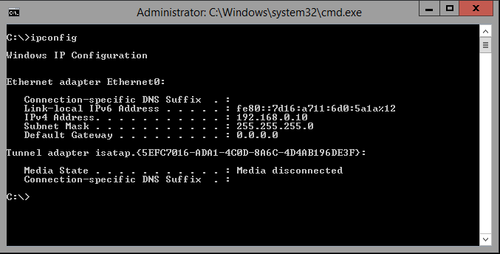

My assigned IP address is 192.168.0.10. Your assigned IP address will differ. Since this is s server, needs to join my syberoffense.local domain and it will be a server, we need to statically configure it with the information it needs to find a domain controller to join by existing domain.

Relaunch the sconfig.cmd. Select option #8 to configure your network settings statically.

Select option #8.

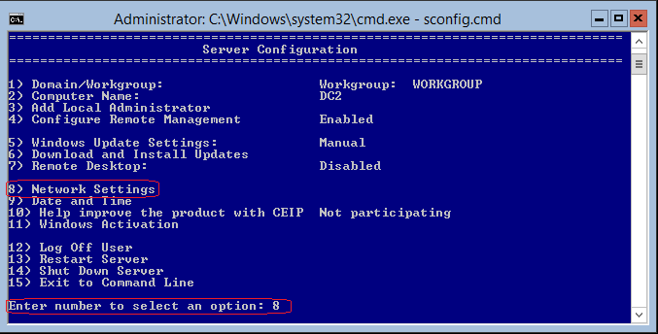

We only have one adapter, so we select this adapter for configuration.

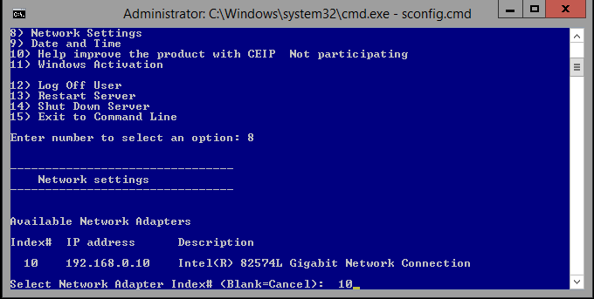

At the next window, we select 1 from the available options to set the network adapter IP address.

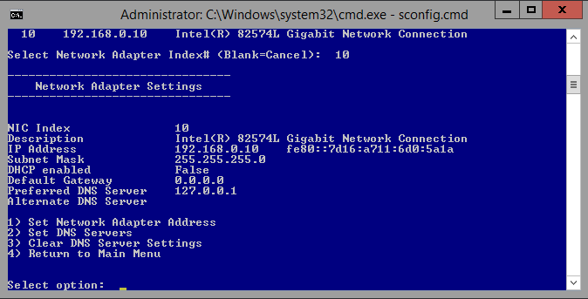

Type in “S” for static.

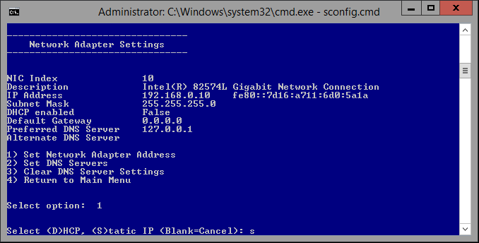

Type in your static IP address.

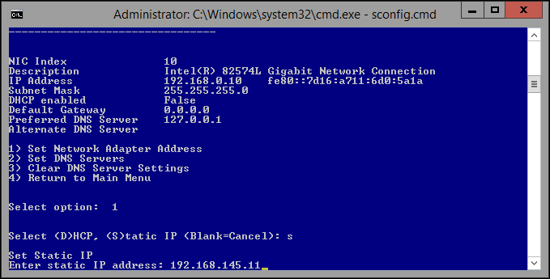

Hit enter to accept the default subnet mask.

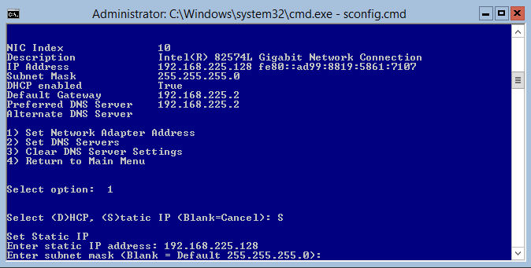

Type in your default gateway. This would normally be the inside address of the LAN interface for your firewall or router. That would usually have a host IP of .1 or .2, not a requirement just the way IP schemes are normally designed.

Once we hit enter with the last needed IP address, we are given the results. We will want to join this server to our domain. To do so we have to tell this core server where the DNS server for the domain is located. This is so it can find the needed DNS server to find a domain controller to authenticate with.

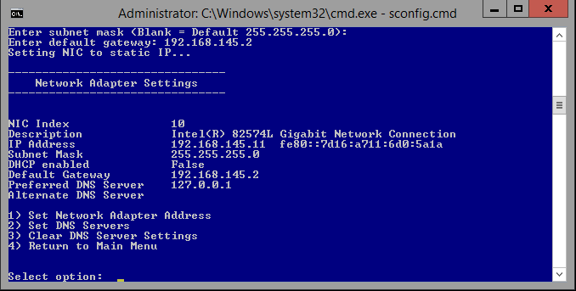

We select option #2 from the available options. The DNS in this example is the IP address of my root domain controller which runs the primary domain for my lab. Your IP address will differ.

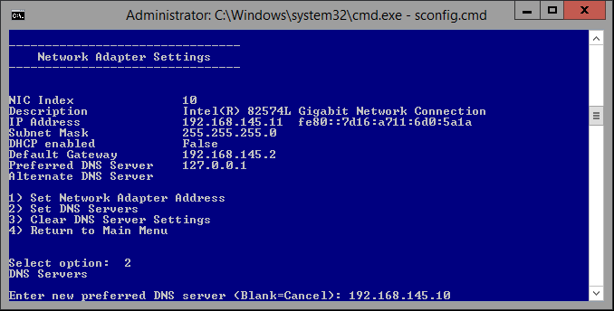

We do not need a secondary DNS as that role will be assigned to this core server later in another lab.

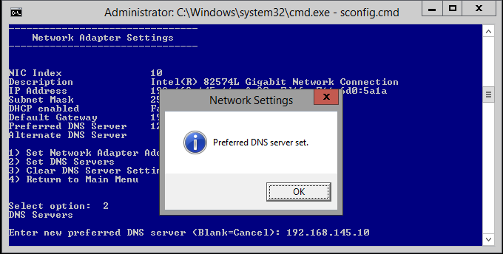

We have statically configured our new Server 2012 Core server. We are now ready to join our server to our existing domain. We type in 4 to return to the main menu and use option 1 to change our workgroup to a domain.

Type in the letter D for. “domain.”

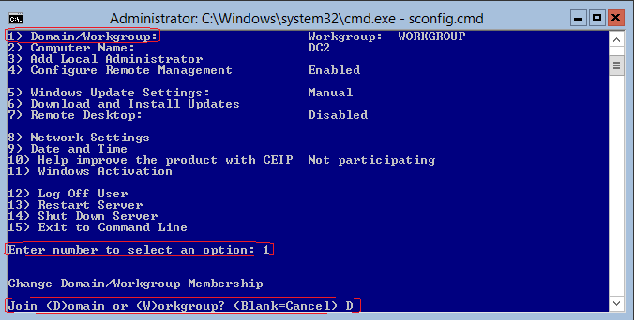

We type in the name of our domain. The name of my domain is syberoffense.local. Yours may differ.

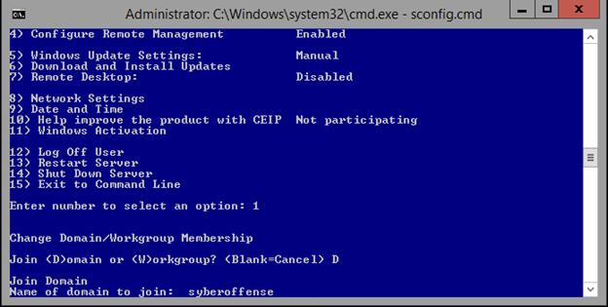

I will use my administrator credentials for the domain to join the server to my network.

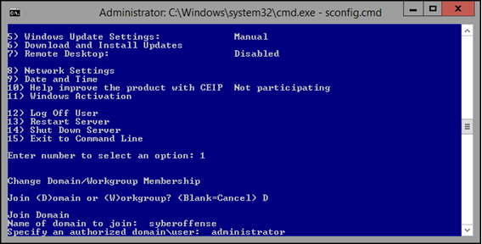

At the command prompt asking for your password, enter your domain administrator password. The password will not show as you type. This is a security feature.

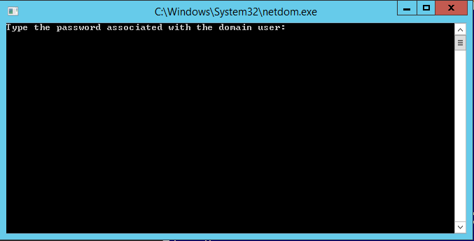

If the domain cannot be found, restart your Server Core so the changes made to the network adapter can take effect. 1

shutdown.exe /r /t 0 /f

When asked if you want to change the name of your computer before restarting, say no.

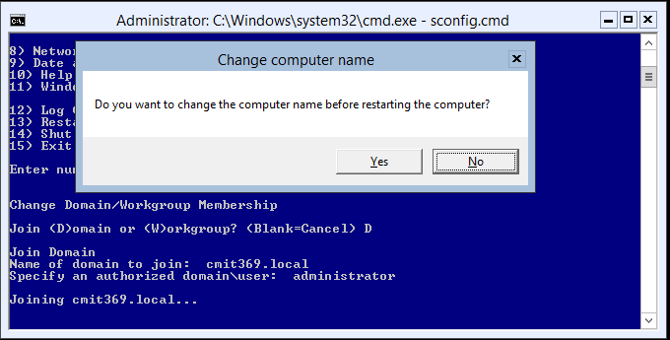

Restart the server when prompted.

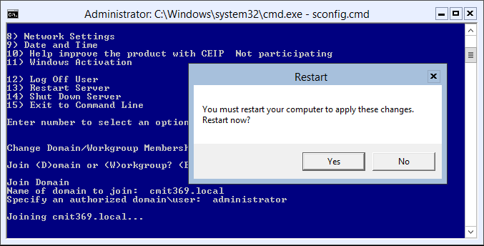

After the server restarts, you can log on as “other user” using your domain administrator credentials. It may take some time for your domain profile to be built so be patient.

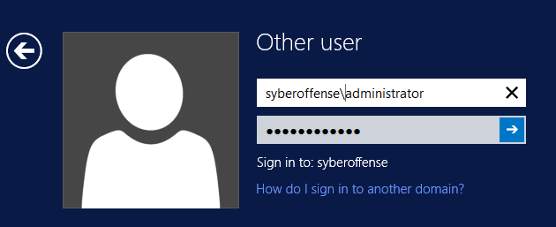

You can check your new domain membership by launching the **sconfig.cmd** utility.

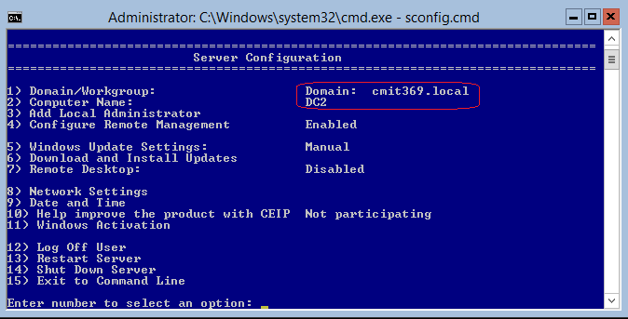

This concludes configuring server core with static network settings and joining the domain.

To shut down your Server 2012 Core machine, use the following command:

**Shutdown -s -t 0**

End of the lab!